# **Valid States Truth Table:**

|  |  |  |  |  |  |
| --- | --- | --- | --- | --- | --- |
| Lower Tank  (low) | Lower Tank  (high) | Upper Tank  (low) | Upper Tank  (high) | Motor | |
| Upper | Lower |
| 0 | 1 | 0 | 1 | 0 | 0 |
| 0 | 1 | 1 | 0 | 1 | 0 |
| 1 | 0 | 0 | 1 | 0 | 1 |
| 1 | 0 | 1 | 0 | 0 | 1 |

# **Flow Chart:**

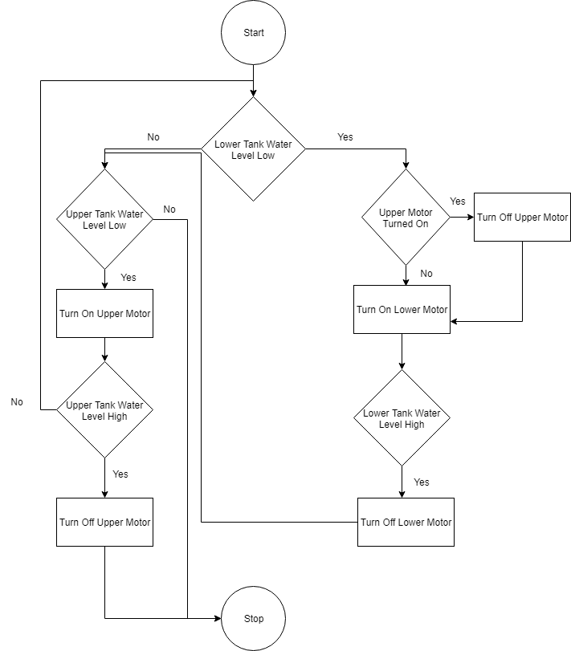

# **Circuit Diagram:**

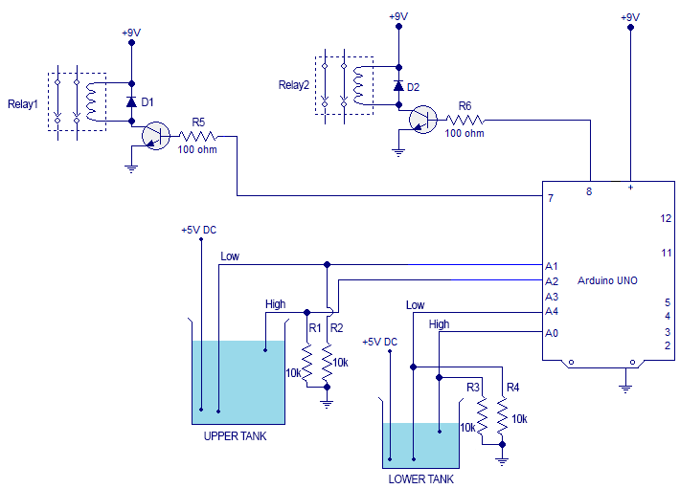

# **Block Diagram:**

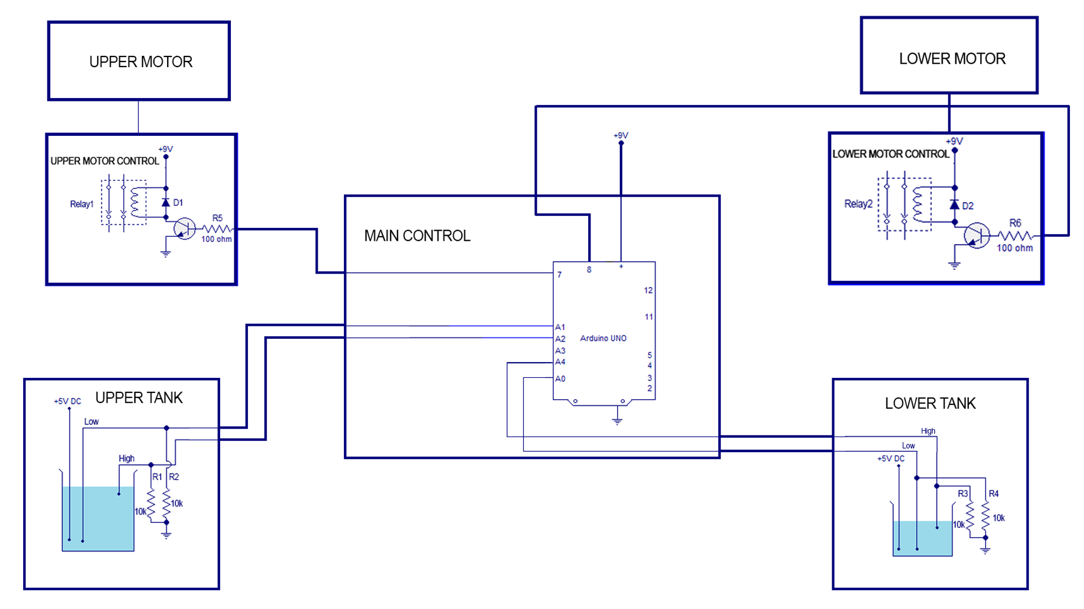

# **Block Diagram (simplified):**

